**Map pointing**

**States with thin forest**

1. **Haryana**
2. **Punjab**
3. **Rajasthan**
4. **Uttar pradesh**
5. **Gujarat**

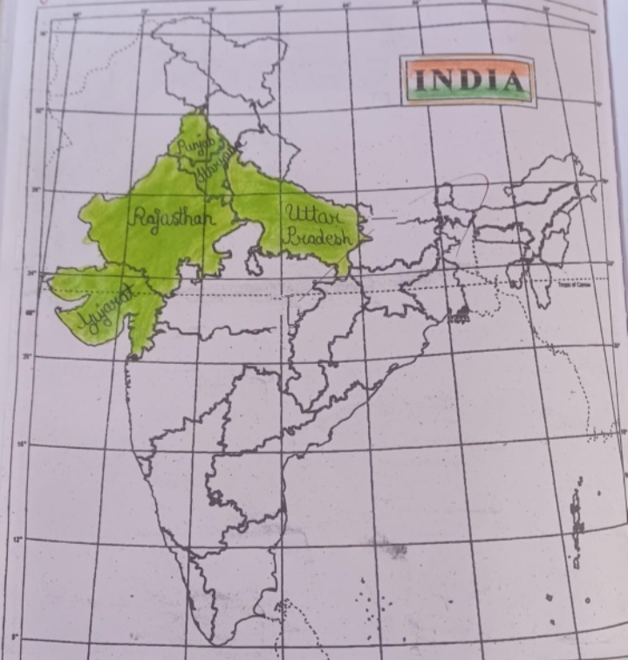

**States with thick forest**

1. **Madhyapradesh**
2. **Arunachal pradesh**
3. **Chhattisgarh**
4. **Orissa**
5. **Maharashtra**

